Impact on teaching in times of Covid-19 pandemic: a qualitative study

Alejandro Almonacid-Fierro¹, Rodrigo Vargas-Vitoria¹ , Ricardo Souza De Carvalho¹, Manuel Almonacid Fierro².

Affiliation

- College of Education, Universidad Católica del Maule, Talca, Chile.
- College of Education. Universidad Autónoma de Chile, Talca, Chile.

The copyright to this article is transferred to Institute of Advanced Engineering and Science (IAES) if and when the article is accepted for publication. The undersigned hereby transfers any and all rights in and to the paper including without limitation all copyrights to IAES. The undersigned hereby represents and warrants that the paper is original and that he/she is the author of the paper, except for material that is clearly identified as to its original source, with permission notices from the copyright owners where required. The undersigned represents that he/she has the power and authority to make and execute this assignment.
We declare that:
1.-This paper has not been published in the same form elsewhere.
2.-It will not be submitted anywhere else for publication prior to acceptance/rejection by this Journal.
3.-A copyright permission is obtained for materials published elsewhere and which require this permission for reproduction.
Furthermore, I/We hereby transfer the unlimited rights of publication of the above mentioned paper in whole to IAES. The copyright transfer covers the exclusive right to reproduce and distribute the article, including reprints, translations, photographic reproductions, microform, electronic form (offline, online) or any other reproductions of similar nature
Likewise, the journal's publication standards are accepted and the article is requested to be evaluated by the Editorial/Scientific Committee of “International Journal of Evaluation and Research in Education”

The present is signed in Talca, october 12, 2020.
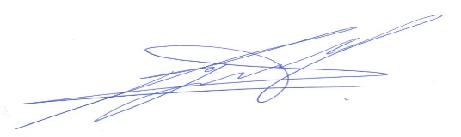

Alejandro Almonacid Fierro
First author
DNI 10.870.516-7

