Appendices.
Parts of test instrument early draft

GATOT DAN TIWUL
POPULAR FOOD OF INFERTILE AREA

1. Food knowledge characteristics of local wisdom in Central Java

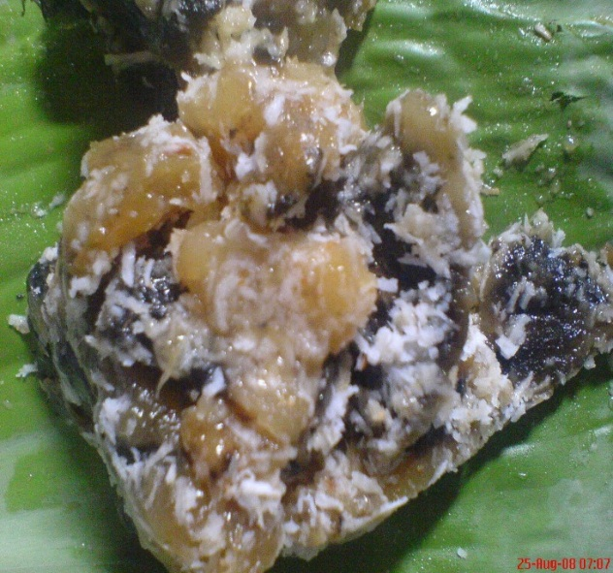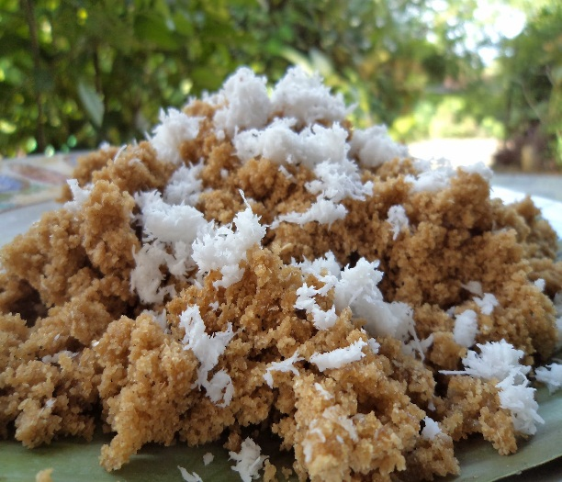
Figure 1. GATOT dan TIWUL as food knowledge characteristics of local wisdom in Central Java

Food in the picture above is an example of local wisdom special food , people called it GATOT and TIWUL which is local food made by gaplek (dried cassava) that is popular in Kidul Mountain starts from Gunung Kidul in Yogyakarta until Pacitan Regency area, East Java. The name GATOT came from ‘GAGAL TOTAL’ because the failure of gaining rice or white gaplek, while TIWUL came from production process which is ‘PATHI di AWUL-AWUL’.
Cassava is yearly tropical and sub-tropical clump. Its root well-known as main food and its leaves as vegetable.
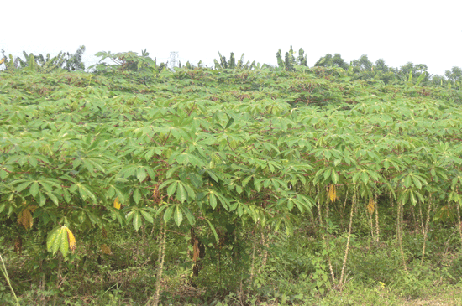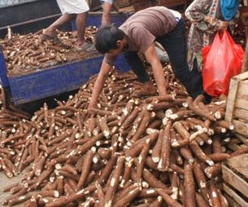
Figure 2. Cassava and harvested cassava.

Mr.Surani, a cassava farmer from Gunungpati said that production process of gaplek is very easy; cassava root, in Javanese called pohung are harvested, peeled, and dried. The dry is done by gaplek makers by drying it in the sunlight. In drying process, the cassavas are laid in the narrow field without any coverage all day and night long. Dried gaplek was mashed as flour and can be stored for month and can be used as delicious TIWUL.
Based on Ngatini’s story, there are two kind of gaplek. First gaplek is white commonly made as flour or TIWUL and second gaplek is black and made as GATOT. According to Mr. Surani, at the beginning it was just for white gaplek, but because the bad process of drying (rain factor), it become black gaplek. The feel of pity if the gaplek is thrown to the garbage, then GATOT was appeared and become popular to the society.
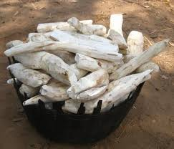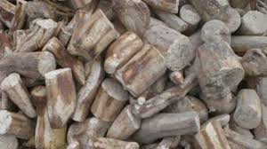
Figure 3. Picture of white and black gaplek as ingredients to make local wisdom special food of Central Java

Answer all of these questions.
From the passages above it is showed that cassava is yearly tropical and sub-tropical clump. The root well-known as main food and its leaves as vegetable.
- a) Give an explanation scientifically how roots and leaves of those cassavas can be made from its plant! (SGS logical frame ). Write down occurred reaction similarity (SGS symbollic language) Score 3
b) Through the scheme of arrow diagrams equipped by picture and label, draw the growing and developing process of cassavas’ roots and leaves in its tree. (SGS modelling) Score 2
- From the farmers’ experience, cassava is one of the food ingredients that is not durable. In the fresh condition it can only survive for three days. If it is saved more than three days, the root will become blue and brownish and will tastes bitter. Farmers said that don’t choose the cassava if there are blue parts in it because it is poisonous. Is it true? Give logical answer! (science process of conclusion evaluation)
Score 3
Test of carbohydrate had been done in the laboratory of fresh cassava, gaplek, and some other food ingredients with the result in following Table
No. Food Ingredients Colors Information
Before Yodiumize After Yodiumize
1 Banana Yellowish Rather Purple Rather Thick
2 Rice White Rather Purple Thick
3 White Tofu White White -
4 Biscuit Brown Agak ungu Quick
5 Flour White Purple Thick
6 Potato Yellowish Purple Rather Pale
7 Fresh Cassava Yellowish Purple -
8 Gaplek Yellowish Purple -

- From the experiment result above, why did the tested white tofu didn’t become purple? (cause and effect law) (science concept comprehension demonstration)
Score 2
- Write down your conclusion related to the experiment result above! (science process of making conclusion)
Score 2

